ARUWE and WECF invite to the
NGO Workshop: Towards the Implementation of the Sustainable Development Goals (SDGs)
Green Technologies and Networking
25-29 September 2017
The workshop will take place at ARUWE Kiboga Regional office and onsite in the villages.
Transport for participants from Kampala to Kiboga and back as well as accommodation will be provided.

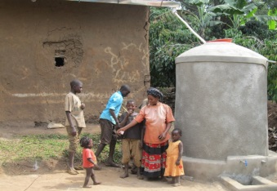 | 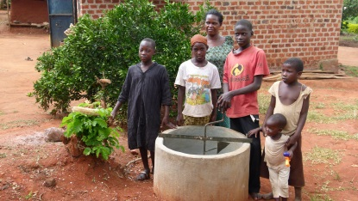 | 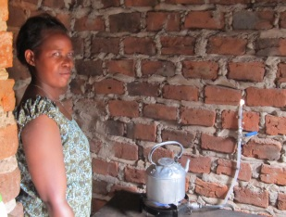 | 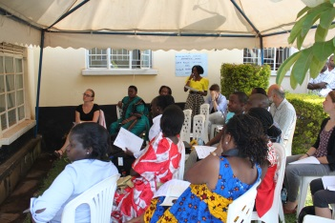

Aims of the workshop:
- Capacity building on green technologies (biogas digesters and rainwater harvesting tanks made of bamboo) and how they can support the implementation of the SDG5, SDG6 and SDG7
- Showing demonstration objects and the process how construct them
- Exchange and sharing of experiences
- Sustainable project monitoring
- Introduction into energy cooperatives
- Identifying common interests with other NGOs and starting to network and cooperation
- Identifying the potential of setting up an informal network for sustainable development among the invited NGOs

Application below
Workshop for Networking and Capacity Building
Proposed workshop Programme
Duration: September 26th-29th 2017

Monday 25th Sept: Travel day (Travel from Kampala to Kiboga)
Timeframe | Session 1 | Responsible Person | Tea  Break | Session 3 | Responsible Person | L un c h  Break | Session 5 | Tea  Break | Responsible Person | Session 6 | Responsible Person
Day 1  Tuesday  26th Sept | 9:00-11:00 |  | Tea  Break | 11.30-1:00 | 10 minutes @ | L un c h  Break | 2.00-4.00 | Tea  Break |  | 4:30-5:30
Day 1  Tuesday  26th Sept | 1.Prayer  2.Introductions  3. Welcome remarks  4.Sharing expectations  5. Sharing agenda | Volunteer  ARUWE (All participants)  WECF  ARUWE  ARUWE | Tea  Break | Organization presentations about who they are and their work  Open discussions after ever after 3 presentations | 1. KAP  2. Hunger project  3. ATU  4.VERDA  5. Katosi Women  6. SWAGEN  7. Ruwenzori e.V Catholic Diocese Kasese  8. Africa Rise E,v  9. ARUWE  10. others | L un c h  Break | 1.Interactive session for mapping and identifying of overlaps of activities of the different NGOs  2.Mapping of existing networks in Uganda (Strengths and Weaknesses) | Tea  Break | SWAGEN  Catholic Diocese Kasese | Moving forward- Identify opportunities for synergies and collaboration for better networking and learning | WECF
Day 2  Wednesday  27th Sept | Case study Presentation on green water and sanitation technologies and women empowerment  Open discussion | WECF and ARUWE | Tea  Break | Case study presentation on water and sanitation for credit | Community Fund | L un c h  Break | Introduction into citizens´ cooperatives, especially energy cooperatives and discussing their potential for Ugandan communities | Tea  Break | WECF | Project monitoring – methodologies – joint session where partners share their best practices | WECF
Day 3  Thursday 28th Sept | Visit ARUWE Agro ecological demonstration farm | Participate in weaving | Tea  Break | Participate in construction of bamboo technology | Participate in construction of bamboo technology | L un c h  Break | Participate in construction of bamboo technology | Tea  Break | Participants demonstrate the use of facilities at the demo farm
Day 4  Friday 29th Sept | Visit ARUWE individual beneficiaries  Visit Hunger project (Epic Centre) | Beneficiary 1  Bio gas-Green technology/bamboo |  | Consolidating lessons learnt and feedback from the field visit  Way forward for the informal network and Action planning  Closing Remarks | ARUWE  WEFC |  | Departure from Kiboga to Kampala | Tea  Break

ARUWE

ARUWE (Action for Rural Women’s Empowerment) is a non-profit, Non-Government Organization working with marginalized groups of people principally rural Women and children. ARUWE registered as an NGO in 2008 and we work to strengthen women’s leadership so that collectively they can break the chains of poverty, patriarchy, class and sexual repression. We support rural women to advocate for economic justice as well as sexual and reproductive health and rights; promote education and lifelong learning; enable communities to adapt to climate change and challenge the negative impact of rigid and oppressive gender stereotypes.
http://aruweug.org/
Mirembe Agnes is a Community Development worker with a working experience of over 10 years. She is the interim Executive Director for ARUWE and she is a graduate from Makerere University-Uganda with an M.A in Ethics and Public Planning (2009). She has got experience and trainings in rural development in the WASH sector, health and institution development and governance etc.

ERBACHER STIFTUNG
The German based ERBACHER Foundation supports development aid intents in rural regions worldwide. Projects especially important are those promoting livestock husbandry, crop production, drinking water supply and environmental protection. Erbacher wants to contribute in making life in rural areas worthwhile living again.
Since a few years, priority countries are Uganda, Tanzania and India where projects are being funded.
www.erbacher-stiftung.de/en.html

Women Engage for a Common Future (WECF)
The WECF Network is a network of 150 member organizations and individual members who share a common concern to promote a just and healthy planet for all, strengthen the role of women and promote a gender and rights based approach in environment and sustainable development policy and implementation.
Over the past 20 years, WECF has developed into an international network where capacity building of the member organizations, joint implementation of demonstration projects, and exchange of experience have become the basis of reciprocal cooperation. In order to reach its goals WECF implements projects in partnership with local organizations in 50 countries.
Dr. Claudia Wendland is water and sanitation expert and promotes re-use oriented sanitation and biogas systems which are adapted to local conditions. Her country expertise is mainly in Uganda, Georgia, Kyrgyzstan, Moldova, Romania and Jordan.
Katharina Habersbrunner is the WECF energy coordinator implementing renewable energy projects with NGO partners in Eastern Europe and Central Asia as well as training of local citizens for installation and maintenance of solar systems and development of financial and institutional mechanisms like citizens´ cooperatives.
www.wecf.eu

Application to the NGO Workshop
Towards the Implementation of the Sustainable Development Goals (SDGs):
Green Technologies and Networking
25-29 September 2017, Kiboga, Uganda
To apply for participation, please fill in the lines below and send an email to the contact below
LATEST BY 31ST AUGUST 2017

Full name, Position, NGO: __________________________________________________________________________________
Sex: Female/Male: ______________________
Phone Number, Email Address ______________________________________________________________________________
Main areas your NGO is working in: __________________________________________________________________________
Which input you want to bring into the workshop? ______________________________________________________________
________________________________________________________________________________________________________
What are your expectations for the workshop? _________________________________________________________________
_________________________________________________________________________________________________________

Action for Rural Women's Empowerment (ARUWE) Plot 800B Block 16 Rubaga Road P.O.BOX 28564 Kampala, Uganda
Office Phone: +256 (0) 312 102 852 Mob: +256 (0) 778 896 317
Email 1: aruwe@aruweug.org Email 2: aruwe.aruwe@gmail.com
Skype: aruwe.aruwe1
Website: www.aruweug.org

We have a limited numbers of places and will let you know as soon as possible about your participation!

